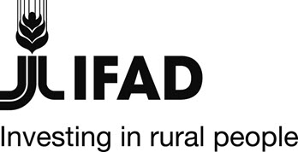 | 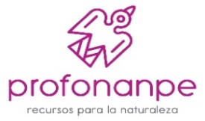 | 

PERU

GRANT – PERU - FSP-022-PER, GEF ID: 3933

Sustainable Management of Protected Areas and Forests of the Northern Highlands of Peru (INKAÑARIS Project.)

GEF Terminal Evaluation Report Summary

Maps of project areas

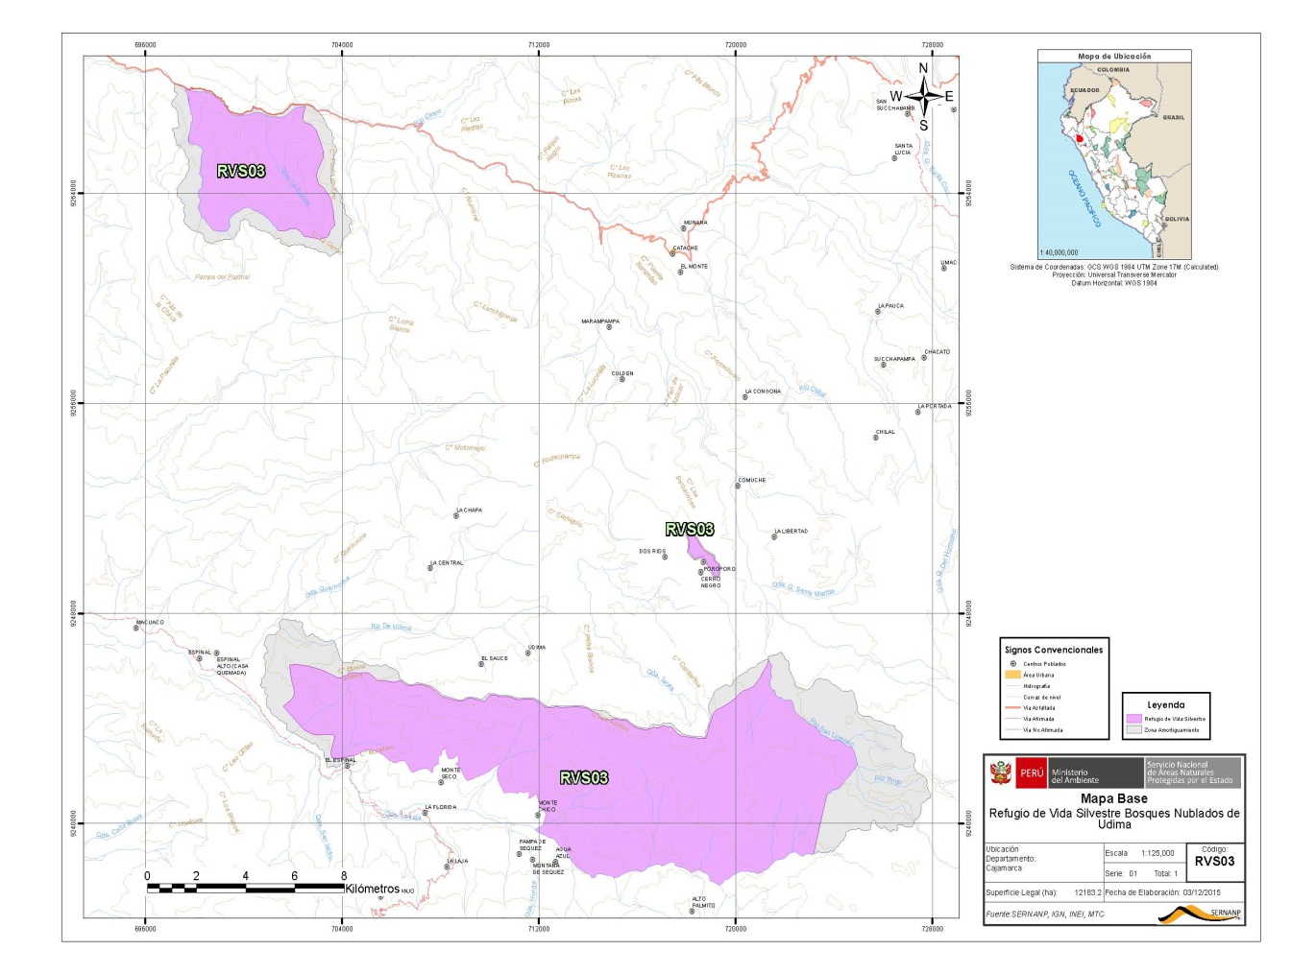

INKAÑARIS Project at a glance

Country | Peru
Project Name | Sustainable Management of Protected Areas and Forests of the Northern Highlands of Peru
Key Dates
IFAD Approval | Signing | Effectiveness | Mid-Term Review | Original Completion | Actual Completion
 | 7 Nov. 2011 | 26-Sept. 2011 | April-2015 | 30-09-2015 | 30-10-2016
Original Grant Closing | Actual Grant Closing
30 Sept. 2015 | 30 Oct. 2016
Project Financing
Grant | US$ million | 1,820,000 | % disbursed | 87%
Remarks: The amounts disbursed and not executed were returned to IFAD and the Sierra Norte Project respectively.
Actual Costs and Financing (USD ‘000)

Component | IFAD-GEF | Beneficiaries | GOVT (Sierra Norte Project) | Total
1. Support for the Regional System of Protected Areas | 210,495 | nda | 78,224 | 18%
2. Sustainable Forest Management in Buffer Zones | 1,097,477 | nda | - | 70%
3. Management, Monitoring & Evaluation | 181,165 | nda | 3,092 | 12%
Total | 1,489,137 | nda | 81,316 | 100%
Number of beneficiaries
Total | Direct | Indirect | Women | Men | Youth
312,748 | nda | nda | nda | nda | nda
Remarks:
Project Objective
To ensure the sustainable and participatory management of protected areas and communal forested lands in the Northern highlands of Peru while addressing existing barriers and threats.
Country Partners
Executing Agency | Peruvian Trust Fund for National Parks and Protected Areas (PROFONANPE)
Government Institutions | Ministry of the Environment (MINAM), the Agro-Rural Productive Development Program (AGRO-Rural-Proyecto Sierra Norte); Regional Governments (GORE); National Service of Natural Protected Areas (SERNANP.)
NGOs/CS | ONF Andina
Other

Project overview
- Background of the project: The Peruvian Government (GoP), through the Ministry of Agriculture and Irrigation (MINAGRI) and its Agricultural Rural Program (AGRO Rural), executed the 5-year loan agreement No. 744 - PE "Strengthening the Assets, Markets and Rural Development Policies of the Sierra Norte" (hereinafter Sierra Norte) with the International Fund for Agricultural Development (IFAD). Its purpose was to improve the capacities of rural producers to value their assets and take advantage of income generation opportunities in the Northern Highlands of Peru. The Sierra Norte project completed its activities in 2015, and its administrative closure held in 2016.
- Complementing the loan, IFAD conducted in 2009 the formulation of a USM$1.8 Biodiversity GEF grant to reinforce the objectives of Sierra Norte. It would aim at supporting additional sustainable activities for forests and biodiversity management by addressing existing barriers and threats while ensuring a sustainable commitment to achieve the established objectives and catalyze the growth of investments, activities, and participation of poor rural inhabitants.
- Initially, the two projects would complement each other in the development of their activities and work together. However, the execution of both projects had different dates of beginning, and successive changes of the work team hindered the articulation and the coordination of activities.
- Approval of the GEF Project: The GEF CEO approved in 2011 the FSP project “SFM Sustainable Management of Protected Areas and Forests of the Northern Highlands of Peru," henceforth INKAÑARIS, with funding of USM$1.8 and national co-financing. Under the coordination of IFAD, the Peruvian Trust Fund for National Parks and Protected Areas (PROFONANPE) executed the project through the IFAD-GEF grant agreement GEF-FSP-022-PER.
- The scope of the project is located in the eastern zone Highlands of the Lambayeque Region that involves two districts of the Ferreñafe Province: Incahuasi and Cañaris. From the third year onwards, actions were extended to the Cajamarca Region, in the Udima Cloud Forests Wildlife Refuge of the Catache District, in the Santa Cruz Province, in the Cajamarca Region.

Project Goal and objectives

- Goal. To ensure the sustainable and participatory management of protected areas and communal forested lands in the Northern Highlands of Peru while addressing existing barriers and threats.
- Objective: Securing the sustainable and participatory management of protected areas and community forestlands of Lambayeque and Cajamarca, with particular emphasis on the districts of Inkahuasi and Cañaris. This objective was performed throughout 1) the support of the regional system of protected areas in Lambayeque and Cajamarca. The specific objective of this component is the conservation and sustainable use of natural resources and to deepen the governance of biodiversity and the environment in the project area, supporting the establishment of a regional network for effective management of protected areas; and 2) Sustainable forest management in buffer zones. The objective of this component was to ensure sustainable management in forest areas in the buffer zones of the protected areas within the project area. To achieve this, the project should support local communities with economic activities that are friendly to the environment, in order to alleviate the pressure of deforestation, as well as contributing to the reduction of poverty. The INKAÑARIS project aimed to work with organized rural families from the districts of Cañaris, Inkahuasi, and Catache, residents of the areas of influence, buffer zones and natural protected areas (ANP, Spanish acronym.)

Project relevance
- The project is in line with the aims and GEF objectives of BD-SO1 and BD-SO2 and with the national policy framework for environmental management, including Peru’s Environmental Code (1990) and the new Law for Flora and Fauna (Law 29317, 2009). In particular, the 29317 Law establishes forest management through timber and non-timber concessions in natural forests and forest plantations. It is also aligned with the priorities of the rural population, especially small producers living in Cañaris and Inkahuasi areas, receiving technical assistance, capacity building and asset transfer services to reduce the risk of depletion of natural resources, particularly in forests and protected natural areas that are aligned with IFAD and GEF interests.
- The INKAÑARIS project is structured in two components: 1) Support to the regional system of protected areas in Lambayeque and Cajamarca and 2) Promotion of forest management in buffer zones of the protected areas considered in the project. The Executing Agency, PROFONANPE, signed inter-institutional cooperation agreements with MINAM, with the National Service of Natural Protected Areas (SERNANP), and with the Sierra Norte Project, which depends on the Rural Agrarian Productive Development Program (AGRORURAL) of the MINAGRI, and with the Regional Governments of Lambayeque and Cajamarca, to carry out joint or complementary activities under components 1 and 2.
- Concerning SO1 “Sustainable Financing of Protected Areas”, the project was not able to specify the financial sustainability of two protected areas, the Upland Wildlife Refuge of Udima (RVSBNU) and the Laquipampa Wildlife Refuge (RVSL), because the Endowment Fund and other support activities were returned to the GEF. However, Project’s actions generated institutional synergies, mobilizing annual funds from public and private institutions, and co-financing from the local organizations.
- Support for SP3 (SO1) "Strengthening Terrestrial Protected Area Networks", through the establishment of a protected area in the Cañaris forest, was only partially covered due to the modification of the intervention area of ​​Cañaris to Udima.

- About SP-5 (SO2), "Fostering markets for biodiversity goods and services", there was no direct contribution from the execution of the project. Nevertheless, it contributed to improving the knowledge of the private sector/consumer of organic products, through the analysis of the viability of forest certification in the scope of the project. Based the above, the INKAÑARIS Project RELEVANCE was rated MODERATELY SATISFACTORY (MS).

Project effectiveness
- While the Mid-Term Evaluation (MTR) described the overall performance as Marginally Satisfactory (MS) because none of the components had its processes and activities completed at that time, the project’s Terminal Evaluation (TER) reconsidered the rating, since all the targets -adjusted after the MTR- were reached. (Except for 1.4, related to the creation of an Endowment Fund and the establishment of a Monitoring and Evaluation System.)
- The evaluation mission of December 2013 confirmed a delay in the execution of activities and, accepting a proposal from SERNANP, recommended to reorient the activities towards an extension of the RVSL area. The MTR ratified this decision in April 2015 and included the readjustments in the logical framework indicator, scheduling the preparation of the dossier for the extension of the conservation mode to be submitted to SERNANP-MINAM.
- Following the MTR, the project executed actions on both components. Notably, the boost of the bi-regional platform activities and the Local Management Councils (LCGs, Spanish Acronym) were carried out, as well as funding from other institutions in favor of the RVSL activities. Component 2 was performed in its totality, especially the activities of the RVSBNU. These actions generated a process of sensitization and commitment of the families towards both wildlife reserves, as well as a horizontal approach with SERNANP that, until then, was characterized by a rejection towards this institution. The elaboration of the RVSL extension file was completed, with SERNANP’s compliance. This document was extensively consulted in workshops with Laquipampa inhabitants and officials in both Chiclayo and Lima.
- The project has contributed to the strengthening of the RVSL and RVSBNU new LCGs in participatory processes, which have developed their respective work plans and management tools. Committed communication materials were developed and broadcasted, highlighting audio-visual materials and user-friendly versions of RVSL master plans.
- Concerning business plans, 24 projects out of 64 were successfully executed in the districts of Cañaris and Incahuasi, as well as in RVSL and RVSBNU. Also, feasibility studies on environmental services payments were completed. The Lambayeque and Cajamarca Regional Technical Teams were trained in the formulation, validation, and evaluation of investment projects in the natural heritage, taking into account the continuity of the public investment project formulation process with the Ministry of Finance (MEF). Project EFFECTIVENESS is rated as SATISFACTORY (S).
Project impacts
- Issues related to the project contribution to impact are not based on evidence deriving from M&E data. The TER observed that the INKAÑARIS project has contributed to increasing the physical assets of the families involved in the business plans (BP), providing them with tools and equipment for business activities and other income-generating activities such as agriculture and agroforestry. The impact on revenues was not quantitatively determined either since no baseline or monitoring system is providing such information.
- Regarding agricultural productivity, the turn of most of the BPs is new, implying that productivity is guaranteed by the technical assistance they have had during the whole execution process; at the closure of the project, the BPs were in an intermediate stage of development. In relation to the levels of productivity achieved, associations are required to record the information that will then allow their identification and analysis.
- Gender equity and empowerment. The project did not mainstream the gender approach into its management tools, nor into the tools available to families. However, during the first stage (2012-2013) of the project, there was active participation of women in rural assessments and validations. In the Project’s last stage, Udima’s BPs registered a significant presence of women.
- The global environmental impact generated by the INKAÑARIS project is based on the project's approach to protecting the environment and natural resources. In this sense, the specific contribution is reflected, on the one hand, by the consolidation of local institutions through awareness-raising actions for the population and by reinforcing the bi-regional platform, strengthening the capacities of professionals and technicians in the regions.
- On the other hand, the project facilitated the development of studies such as the "Forest Certification Feasibility Study." Forest certification was aimed at ensuring that the origin of the timber in the forest areas was in line with the Forest Stewardship Council standards. This approach required the involvement of local people and communities who would internalize the importance of certification and should make corrections in productive management. These "management improvement costs" were covered by GEF resources. At this early stage, the project also funded the consultancy "Compilation of historical information on forest geo-reference and systematization of forest aptitude, planting, and protection" to identify areas of forestry suitability in the Inkahuasi district. Finally, the project also contributed to the study on payment for environmental services.
- Monitoring & Evaluation: Even though the project lacked a proper M&E system, as initially proposed, PROFONANPE regularly informed the Project Management Board and IFAD about the progress and limitations of INKAÑARIS, through semi-annual reports, annual reports, audit reports, PIR and Tracking Tools. Also, two IFAD visits were made, which allowed adjusting the project according to the reality of the moment. In this way, the monitoring efforts stood out despite the absence of the system and the TER granted the M&E criterion with a MODERATELY SATISFACTORY (MS) RATING.

Project efficiency
- INKAÑARIS experienced structural changes in its original design: Its components related to integrating rural development and environmental protection seem very ambitious, given the grant amount and the implementation time, and involved coordination of activities that did not take place. In particular, the coordination with the Sierra Norte project financed by IFAD was jeopardized. The GEF initial outputs were modified in all its components, and the amounts that were not used were sent back to the IA.
- Achievement analyses were performed on each of the modified project components, which together represent 88% of the investment made, while 12% was spent on management, administration, monitoring, and evaluation. It was not possible to consolidate the evaluations into a general grade since there is a risk of overestimating or underestimating the specific qualifications in the calculation of a general average. Some indicators are not reliable enough because of the absence of a baseline and a monitoring system; the different nature of the components, as well as activities and assumptions on the impact of the project in the areas of influence. In this context, and taking into account the quantitative information available specifically for business plans, the economic and financial evaluation has been carried out from the cost-benefit calculation:
- Eleven out of twelve (11/12) Business Plans (BP) of Cañaris and Inkahuasi Districts that started in 2012 and signed in 2013 were analyzed. The financial profitability revealed a potential for success in business lines that have significant demand in the local market. Export companies that visited these BPs expressed a purchase interest of: aguaymanto (Physalis peruviana), edible mushrooms, and “Colombian” granadilla (Passiflora ligularis.) The business plans of chamomile have turned into cultivation of aguaymanto; this change also guarantees a high commercial potential and the consequent profitability.
- Regarding the BPs of 2015, they are still under execution, and given the conditions for improving supervision and management of productive initiatives, the financial analysis foresees positive economic returns, except for the case of cocoa; this situation may be because cocoa is a shade-sensitive crop.
- The TER rate of this criterion took into account the progress and achievements of the project after the MTR to the closure of the project. In this way, it is evident that almost all the goals adjusted from the MTR have been achieved. PROJECT EFFICIENCY IS RATED AS MODERATELY SATISFACTORY (MS).

Sustainability
- The investment of the project through the Comprehensive Territorial Management Plans and the BPs has allowed the involved population to recognize and value their resources, taking into account the implications of poor management. Project beneficiaries managing BPs have acquired, at a basic level, the capacities, and individual/collective skills for the sustainable management of natural resources and productive development.
- ENVIRONMENTAL SUSTAINABILITY. Sensitivity campaigns and consensus building within society to the environment, its care and protection must be strengthened with subsequent actions. The awareness and change of attitude require sustained efforts over a more extended period. Another contribution of the project has been the financing of studies that PROFONANPE could formally socialize and distribute. The contribution to the development of capacities in the technical teams also adds favorably to environmental sustainability. SERNANP should continue to prioritize actions to adapt to climate change. For all the above, the risk rate is LIKELY (L).
Partner performance
- Agrorural was the major partner, through the Sierra Norte Project; its support was not performed as described in the design report. The methodological transfer for the use of tools, validated by IFAD projects, was very weak. There was a contribution of US$ 123,000 for Subcomponent 1.1, which was partially executed. Sierra Norte was member of the Project Management Board and, for this reason, its role should have been more compelling, but it is clear that it was not the case because of its own management rotations (three managers throughout the project’s life). Furthermore, the design did not foresee an allotment to allow the project to fulfill its monitoring and evaluation (M&E), supervision and advisory work.
- SERNANP had a significant and collaborative participation in the completion of the project. Regional Governments (GORES) have been actively involved in the process and have benefited from the project's support, which has maintained commitment through the bi-regional platform. Local governments have had marginal participation. The participation of organized families that were part of the project implementation process was essential to the achievement of project results. PROFONANPE's role in the execution and supervision of the project was notable.
- GEF supervision and support: The GEF, through IFAD as executing agency, developed follow-up measures to approve the proposed readjustments of indicators. This supervision action was decisive insofar as, knowing the complexity of the logical framework and the change of several coordinators of both the Sierra Norte and INKAÑARIS projects, it was possible trace a critical route to complete the Project.

Good practices and Lessons learned
- SERNANP and the GORES, thus integrating Local Governments, must now continue the leadership work that facilitated the project. The transfer of funds through public competitions, throughout the Local Resource Allocation Committee, has been useful in motivating the trust and commitment of organized families within SERNANP goals.
- The linkage of the Ministry of Environment with the Ministry of Agriculture, through project actions for conservation areas and provision of productive opportunities to the population in buffer zones and protected areas, is unique in the country and can be a reference for other countries with similar situations.
- Generating participatory processes for sustainable management in protected areas that are installed in previous settlements require gradual actions to sensitize and involve actions that can give opportunities and, simultaneously, obligations to organized families. In this sense, the experience initiated by UDIMA must serve to feed a process of monitoring and systematization of guidelines for future interventions.
Recommendations
- The M&E system must be fully integrated from the beginning of the project to generate relevant information for timely decision making, as well as allowing the closure of the project to account for results and impacts.
- The organization of projects, that link productive development with conservation, requires a rural territorial approach, which facilitates the participation of all the agents of this area throughout the project’s life cycle, so as to ensure the sustainability of the objectives and strategies redefined by the stakeholders.
- The generation of participatory processes for sustainable management in protected areas that are installed in previous settlements requires gradual actions to raise awareness and involve activities that can provide opportunities and, at the same time, obligations for organized families. In this sense, the experience initiated by UDIMA should serve to feed a process of monitoring and systematizing guidelines for future interventions.
- The experience gained in the project shows the need to create institutions dedicated to the revitalization and facilitation of local and regional coordination spaces. There are regional and local political wills, but the lack of financial resources and technical assistance limits the development of these synergies. INKAÑARIS enters a bi-regional area that already existed formally but did not act in practice, unlike the management committees that were able to develop and disseminate their master plans. For this reason, future projects should consider these actions in their programs and budgets, but with a plan to transfer responsibilities from the beginning, to ensure their continuity when the project concludes.
- INKAÑARIS experience shows that its design must be conceived to contribute to institutional learning; in this sense, the knowledge generated must be systematized, and the information must be appropriately structured and organized.
- Projects linked with conservation of Protected Areas require an intervention model based on local resources that are built through training and follow-up action. These local resources should participate in the project structure as facilitators, animators, and would constitute, at the closure of the project, skilled human capital in the area.
- The execution of the INKAÑARIS project shows that the management of a project of this type requires that the team of professionals assume greater responsibility and commitment for the integral operation and its results. In this sense, the option of a local team is better than that of a team of consultants who, once finished the product for which they were hired, do not remain or realize the sustainability of the work done.
- Institutional and sectoral synergies, achieved locally, positively favor the execution of projects linked to protected areas and their conservation by developing a feedback work for the detection of needs and their timely response. To reinforce the incidence of institutional work, it is necessary to incorporate those institutions that have the competencies and strengths to complement the work that is done at the project level. Synergy efforts involve civil society organizations, private organizations, and government agencies. In this sense, the synergy between two Ministries such as the Environment and Agriculture is an experience that should be enhanced, involving Regional and Local Governments.

Project Performance Rating Summary

- Component/criteria | - Rating
- Relevance | - Moderately Satisfactory (MS)
- Effectiveness | - Satisfactory (S)
- Efficiency | - Moderately Satisfactory (MS)
- Sustainability (risks) | - Likely (L)
- Monitoring and Evaluation (M&E), M&E Design, Implementation Plan, and Budget and Financing. | - Moderately Satisfactory (MS)

